JavaScript – Part 2 Intermediate Exam – 16 May 2013 Variant 1

Exam terms – Read carefully!
During the exam you are allowed to use any teaching materials, lectures, books, existing source code, and other paper or Internet resources. Direct or indirect communication with anyone in the class or outside the room is absolutely forbidden. This includes but does not limit the restrictions to: technical conversations with other students, mobile phones usage, chat software, email, forum posts, etc.
All students who ignore our rules and cheat during the exam will be disqualified from all our courses.
You have exactly 6 hours to solve all given problems. Good luck!
No external JavaScript libraries can be used (like jQuery, KendoUI, etc…).
The sample UI and code snippets are not obligatory and are not necessary to follow.

Implement a GridView Control

Task Overview
Implement a GridView control having the following characteristics:
- The GridView can have many rows and columns
- A GridView may have a header, containing the names of the columns
  - Only one header can be present for a GridView
- Each of the rows contain the same number of cells
- A collapsed row can be expanded to show more detailed information
- An expanded row can be collapsed to hide more detailed information
- An expanded row can contain another GridView

General Requirements: Overall implementation of the tasks
- Escaping of the strings
  - <br /> should be visualized in the GridView as "<br />" and not as new line
- Using object-oriented principles
  - Creating function constructors for GridView and GridViewRow
  - Use module or prototype pattern
- Cross-browser implementation
  - The GridView should work on Chrome 26, Firefox 20, Opera 12 and IE 8, 9 and 10
Up to 20 points

Task 1
Implement functionality for dynamically adding rows to the GridView
- Adding header row to the GridView
  - A GridView can have zero or one header row
- Adding rows to the GridView
var schoolsGrid = controls.getGridView("#grid-view-holder");
schoolsGrid.addHeader("Name", "Location", "Total Students", "Specialty");
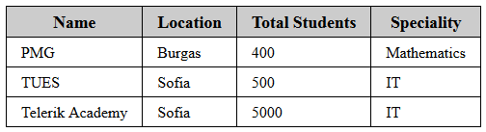
schoolsGrid.addRow("PMG", "Burgas", 400, "Math");
schoolsGrid.addRow("TUES", "Sofia", 500, "IT");
schoolsGrid.addRow("Telerik Academy", "Sofia", 5000, "IT");
schoolsGridview .render();
Up to 10 points

Task 2
Implement functionality for adding nested GridView inside a row of a GridView
- Each GridView row can contain a nested GridView (zero or one)
var academyRow = schoolsGridview.addRow("Telerik Academy", "Sofia", "5000", "IT");
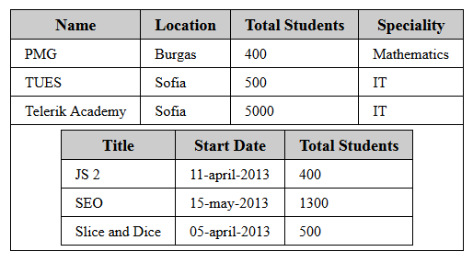
var academyGrid = academyRow.getNestedGridView();
academyGrid.addHeader("Title", "Start Date", "Total Students");
academyGrid.addRow("JS 2", "11-april-2013", 400);
academyGrid.addRow("SEO", "15-may-2013", 1300);
academyGrid.addRow("Slice and Dice", "05-april-2013", 500);
Up to 16 points

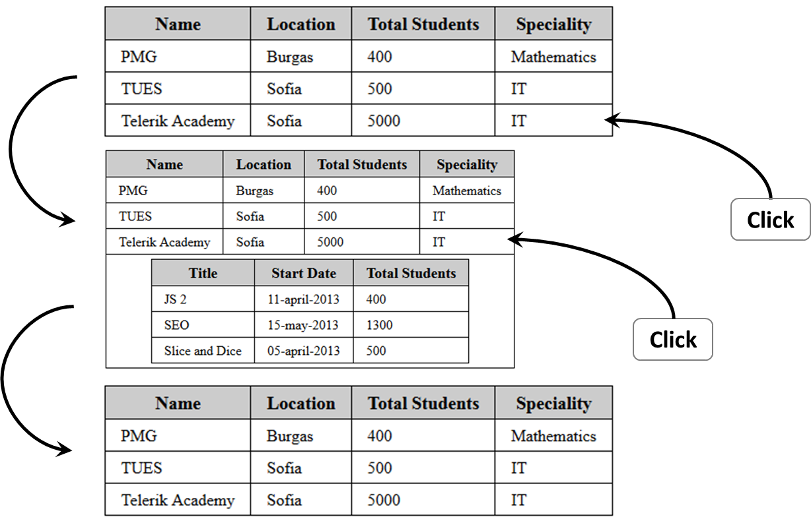
Task 3
Add expand/collapse behavior
- When a row is clicked, its nested GridView should be expanded/collapsed
- If the nested GridView is collapsed, it must be expanded
- If the nested GridView is expanded, it must be collapsed
- If no nested GridView, the click should do nothing
Up to 11 points

Task 4
Create a schools repository using local storage, containing schools, courses and students
- Schools have a name, location, number of courses, specialty and may contain a set of courses
- Each course has a title, start date, total students in this course and may contain a set of students
- A student has a firstname, lastname, grade and his/hers mark in the respective course
- Implement a schoolsRepository object that provides functionality for saving and loading school data from localStorage
var schoolsData = [ /* set of schools, containing sets of courses, etc… */ ];
schoolsRepository.save ("schools-repository", schoolsData);
var data = schoolsRepository.load("schools-repository");
Up to 6 points

Task 5
Implement functionality to get the data from a GridView and save it into a schools repository:
- Get the school's properties from a row and save them in a school object
  - From its nested GridView get the courses’ information, etc…
- Assume the GridView always contains valid school repository data
var schoolsGridView = controls.getGridView("#schools-grid-view");
//add correct schools repository data to the GridView
var schoolsData = schoolsGridView.getGridViewData();
schoolRepository.save ("schools-repository", schoolsData);
Up to 12 points

Task 6
Implement functionality to build a GridView using the data from a schools repository:
- Assume the data from the repository is valid school data
- Create a GridView for the schools
  - Each school has one row in the GridView
- Create a nested GridView for each of the courses in each school row
  - Each course has one row in the nested GridView
- Create a nested GridView for the students in each course row
  - Each student has one row in the nested GridView
- All GridViews have their respective header rows
var schoolsData = schoolsRepository.load("schools-repository");
var schoolsGridView = controls.buildGridView("#schools-repository", schoolsData);
Up to 15 points

Task 7
Implement dynamic resizing of all images

- When a cell in a header row is clicked, all the rows in this GridView are sorted either alphabetically ascending or alphabetically descending
  - Sort only the rows in the current GridView, and not its parent or nested GridViews
Up to 10 points

